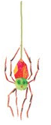

This week we are learning about Day and Night as a part of our Science Curriculum. For example, we are learning about the day and night sky and day and night changes.

The students are expected to explain for the report card that day changes to night at sunset and that night changes to day at sunrise.

December 1, 2016

We hope everyone had a wonderful Thanksgiving Break! I can’t believe Winter Break is only 2 ½ weeks away! With that being said, the end of the nine weeks is almost here! This means it is that time again where we assess each student individually to see what progress they have made to document on his/her report card. Can you believe that your child is half way done with Kindergarten? They sure do grow up fast, that’s for sure!



This week we focused on reviewing our number sense and counting standards.

The next two weeks, we will focus on Measurement. The students will be learning the basics of length, height, weight, and capacity. We will be using vocabulary such as: shorter, taller, longer. heavier, lighter, etc. to describe ways an object can be measured and to compare how two objects are similar or different.

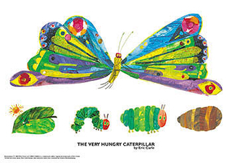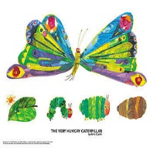

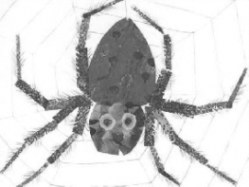





December 1, 2016

**Our Elf, Ginger!**

I am sure your child has told you all about our elf named, Ginger, who arrived Monday from the North Pole. Ginger delivered Elf Applications and ALL the students were approved by Santa to become one of his “official” elves. The students filled out there special Elf IDs and are ready to help Santa. Santa has asked the students to help him spread Christmas Cheer in the next couple of weeks. So, be sure to ask your child how he/she is spreading Christmas cheer!



December 3rd—Saturday Spectacular 9:00-1:00

December 19th—Holiday Party

December 22nd-January 4th Holiday Break

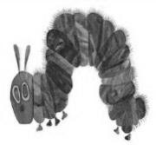



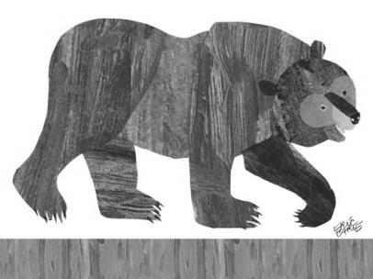

Kintyn

<http://theverybusykindergarten.weebly.com/>